**Screenshots of results**

* If the live video feed is on and real-time gesture recognition results are available, then ‘Calculator ready’ message appears for the first three seconds as shown in Fig. 6. If the user moves the hand (left or right) away from the webcam at any stage, then the calculator resets.

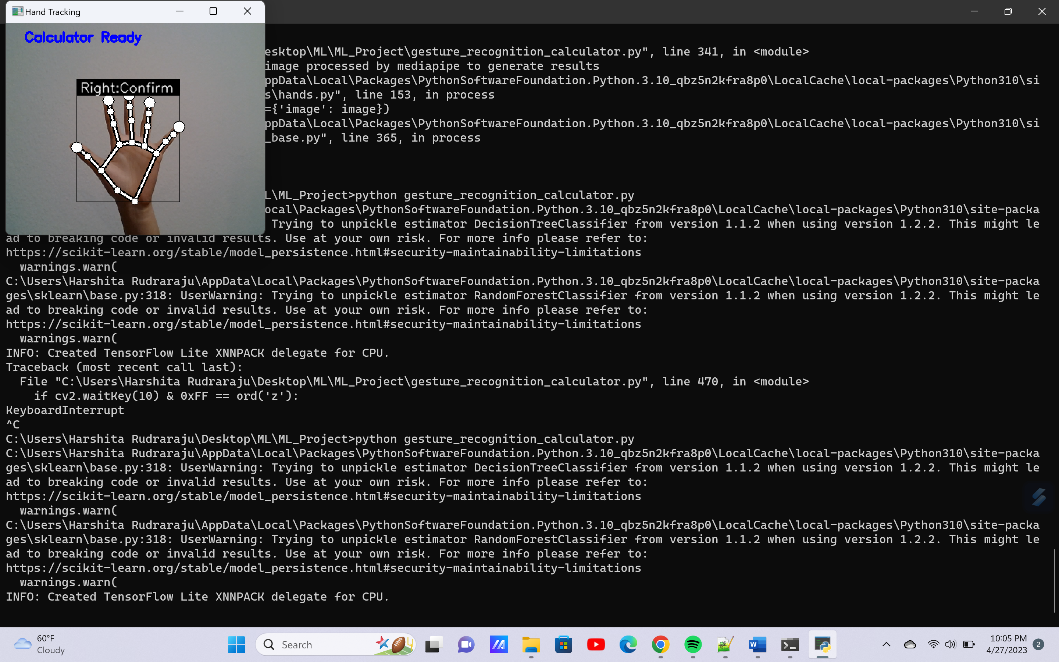

Fig. 6 Initialize virtual OpenCV calculator

* Next, ‘Enter the first number’ message appears for the next two seconds as shown in Fig. 7. The user then needs to show gestures to enter the first number entry into the calculator.

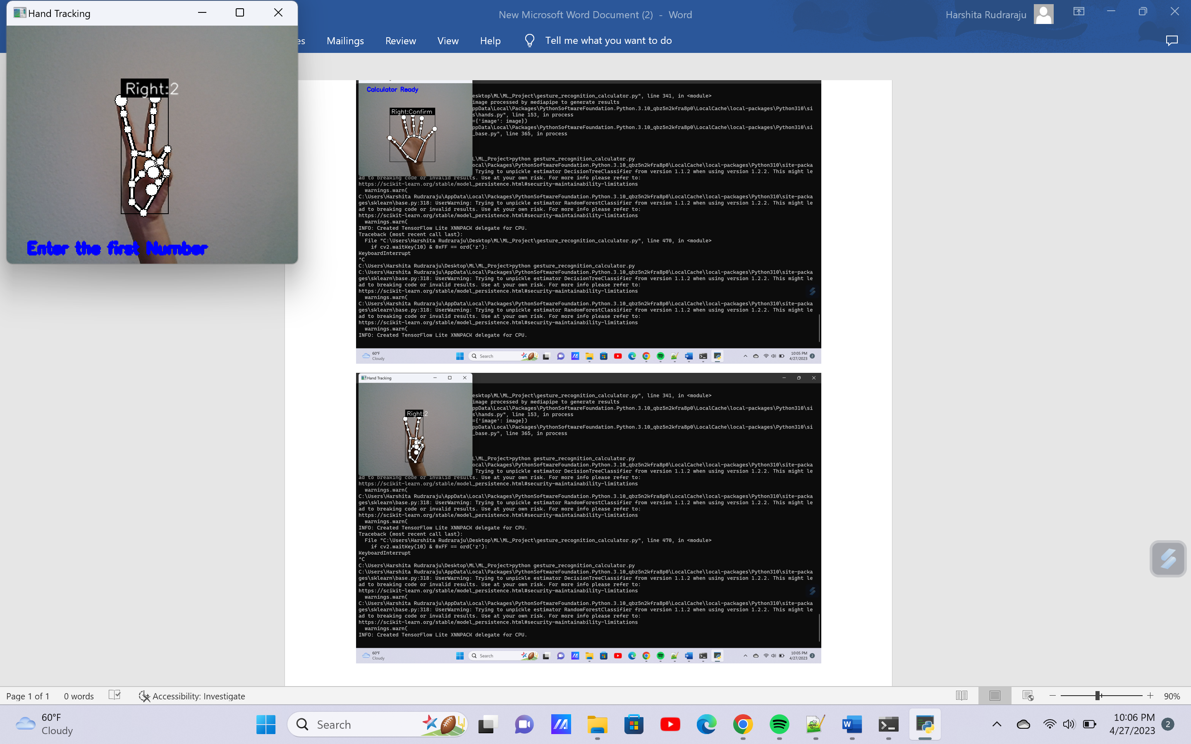

Fig. 7 Enter the first number entry

* The user has a total of nine seconds to enter the first number entry (three seconds for each digit and hence, maximum of three digits). For a digit entry, the user needs to show a gesture for three seconds for it to be recorded by the calculator. Once a digit entry is confirmed, it will appear on the screen as shown in Fig. 8. The user then shows a gesture for the next digit entry and so on, until all three single digit entries are recorded by the end of nine seconds. The user has an option to enter a single/two digit entry as the first number into the calculator and this can be done by showing ‘Confirm’ gesture after the single/two digit entry is recorded (before the end of nine seconds). The user can also clear an entry by showing ‘Clear’ gesture and then, can re-enter the digits. Once the first number entry is confirmed, it appears on the live feed as shown in Fig. 9.

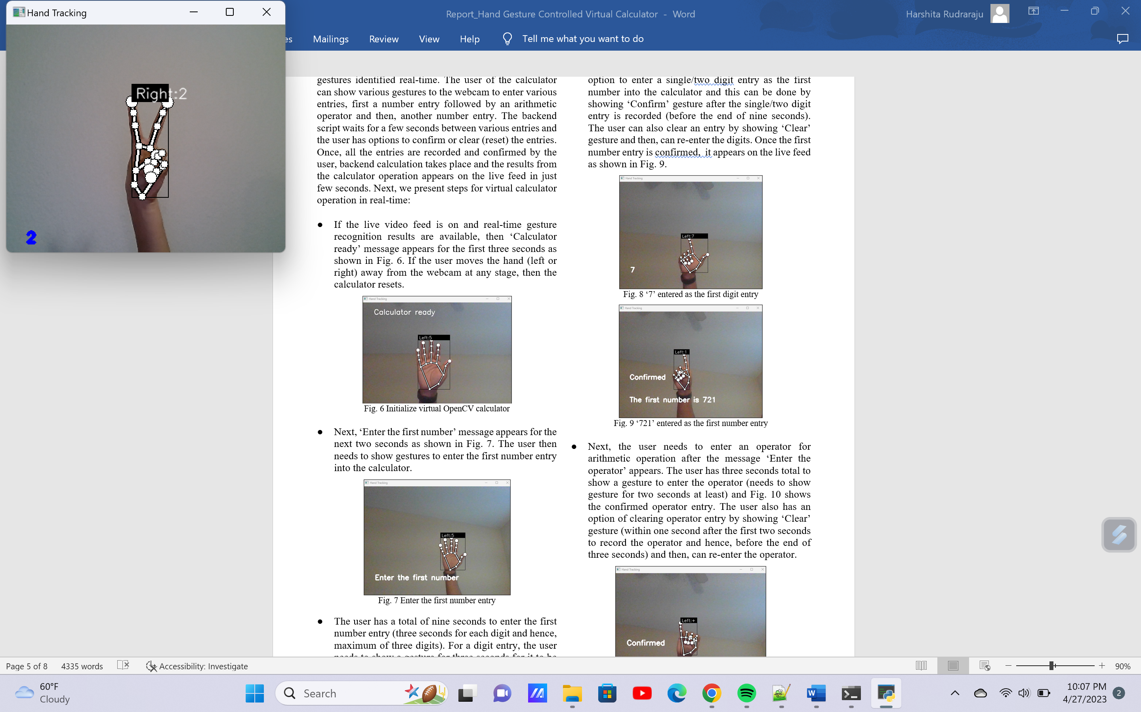

Fig. 8 ‘2’ entered as the first digit entry

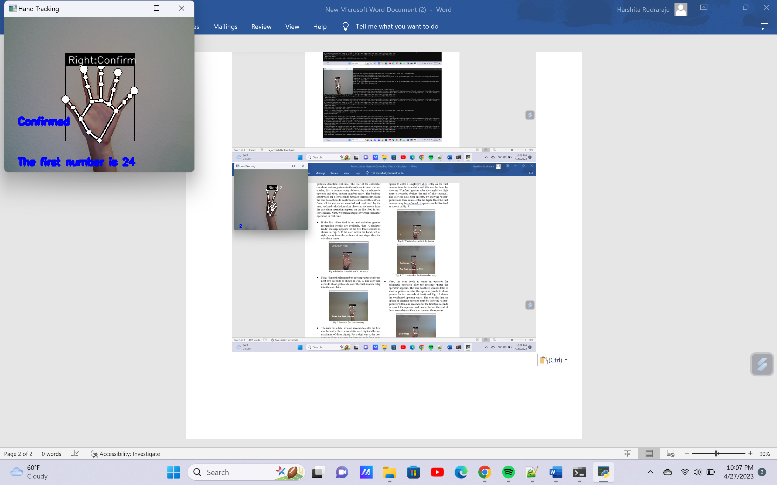

Fig. 9 ‘24’ entered as the first number entry

* Next, the user needs to enter an operator for arithmetic operation after the message ‘Enter the operator’ appears. The user has three seconds total to show a gesture to enter the operator (needs to show gesture for two seconds at least) and Fig. 10 shows the confirmed operator entry. The user also has an option of clearing operator entry by showing ‘Clear’ gesture (within one second after the first two seconds to record the operator and hence, before the end of three seconds) and then, can re-enter the operator.

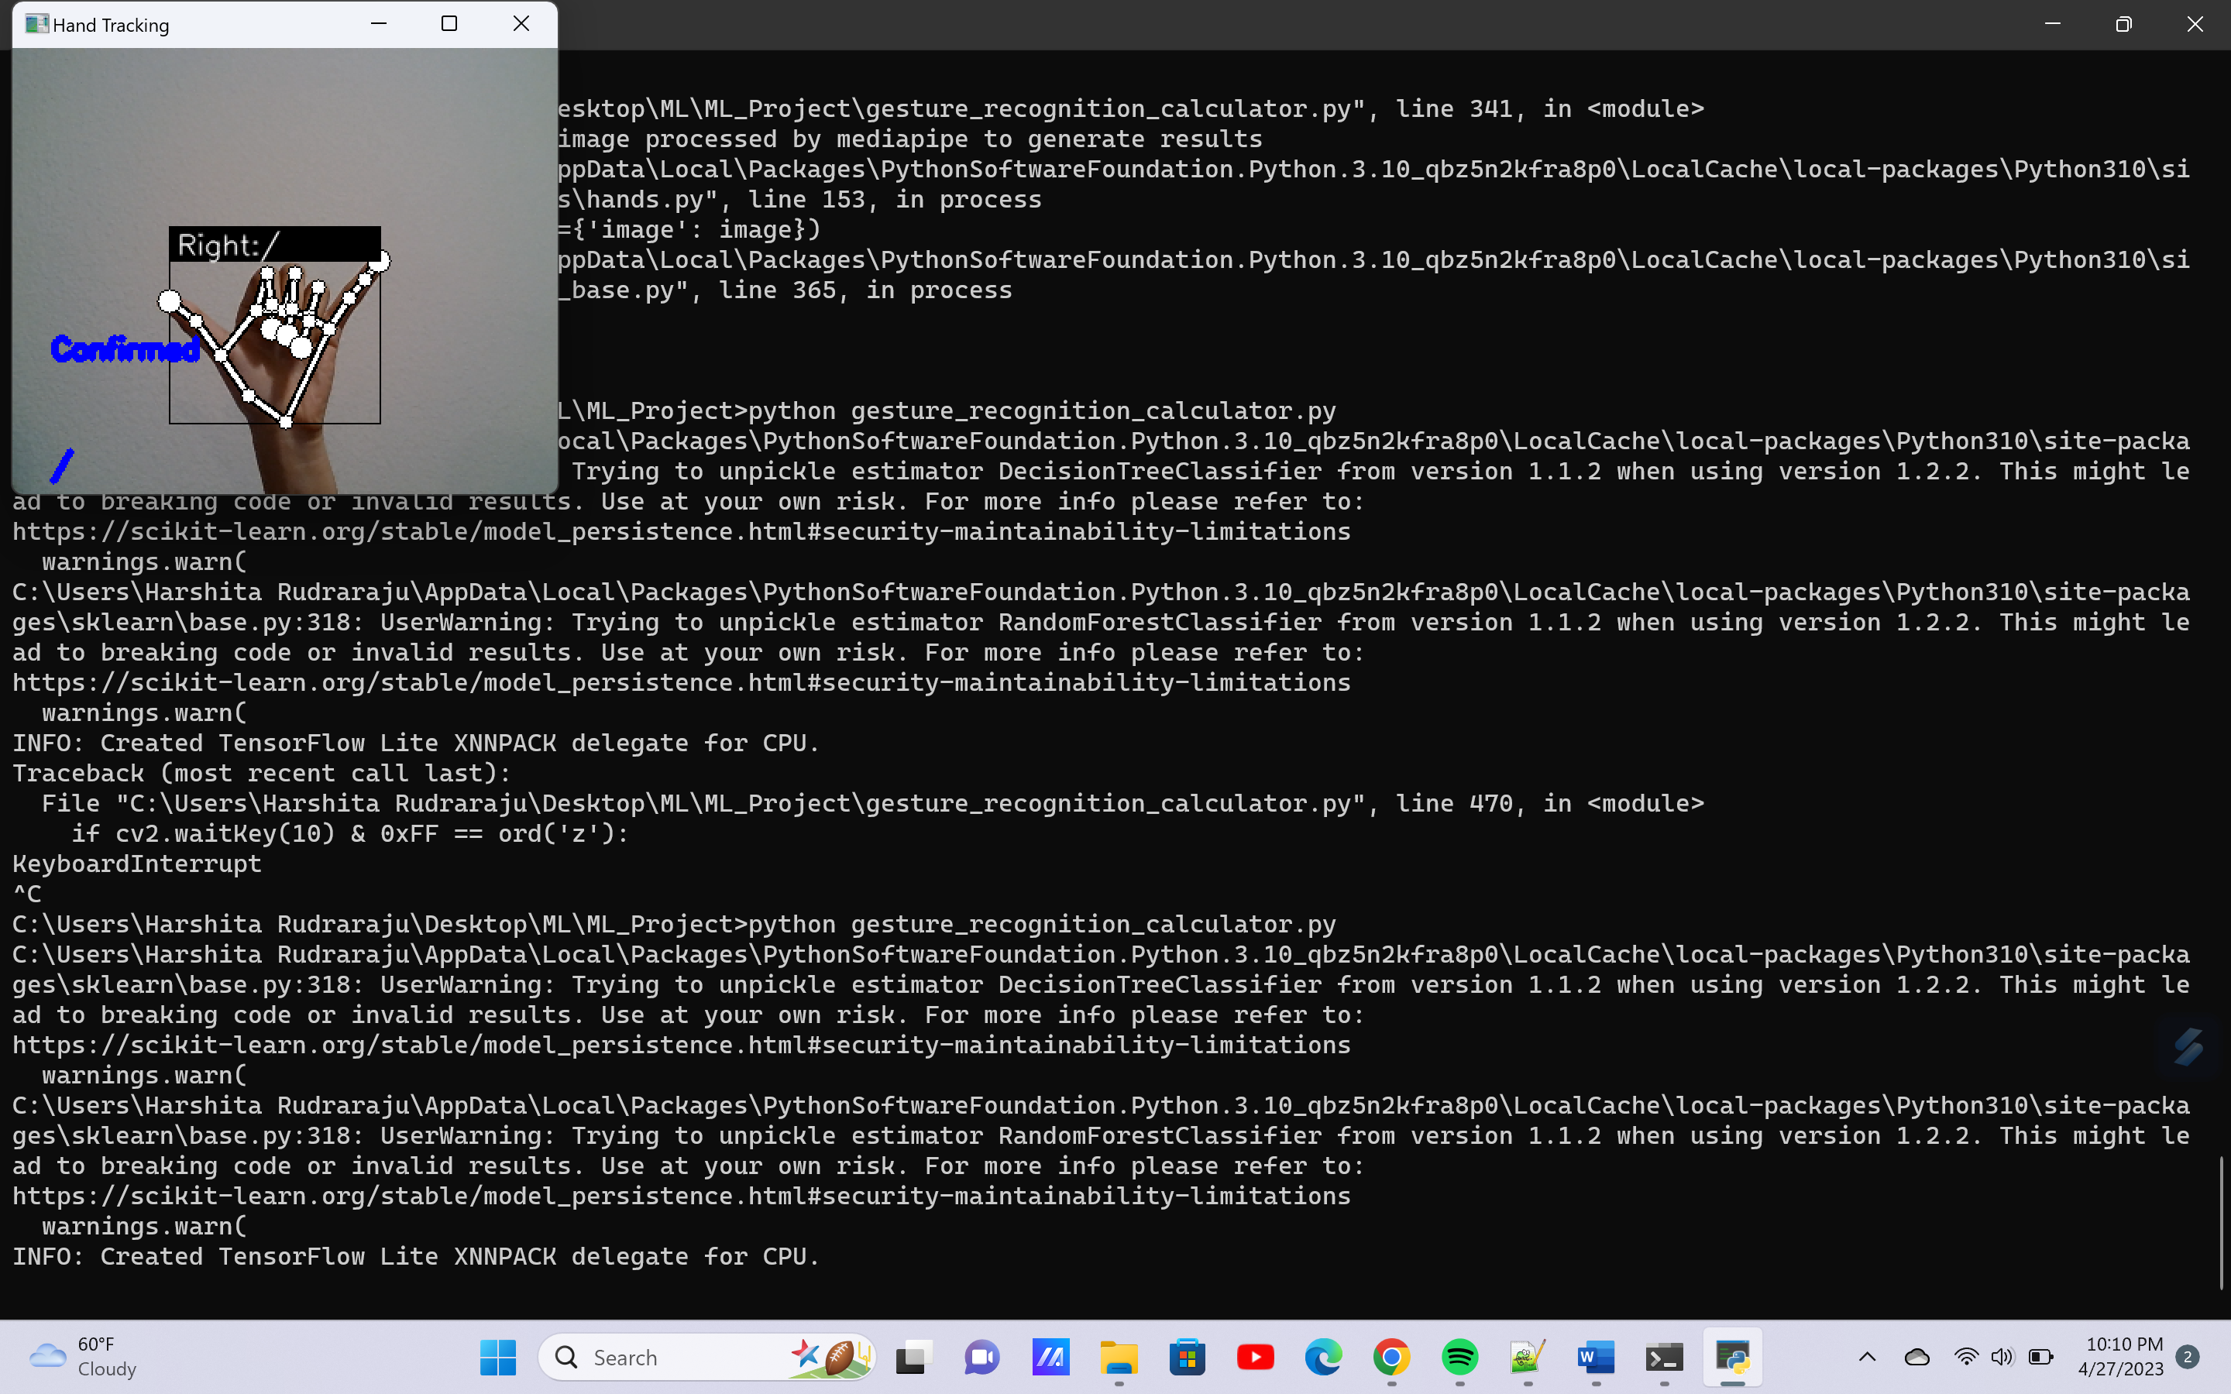

Fig. 10 ‘/’ operator entered

* Likewise, the user can enter the second number entry after the message ‘Enter the second number’ appears. Similar to the first number entry, the user has a total of nine seconds to enter the second number entry (three seconds for each digit and hence, maximum of three digits). Fig. 11 shows the second number entered for the demonstration.

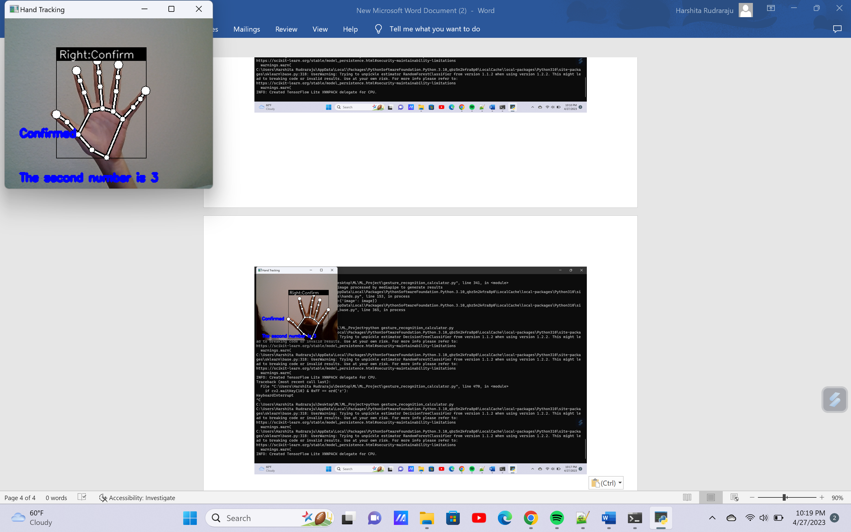

Fig. 11 ‘3’ entered as the second number entry

* Within the next few seconds, the result appears on the screen as shown in Fig. 12. The result stays on the screen for the next nine seconds.

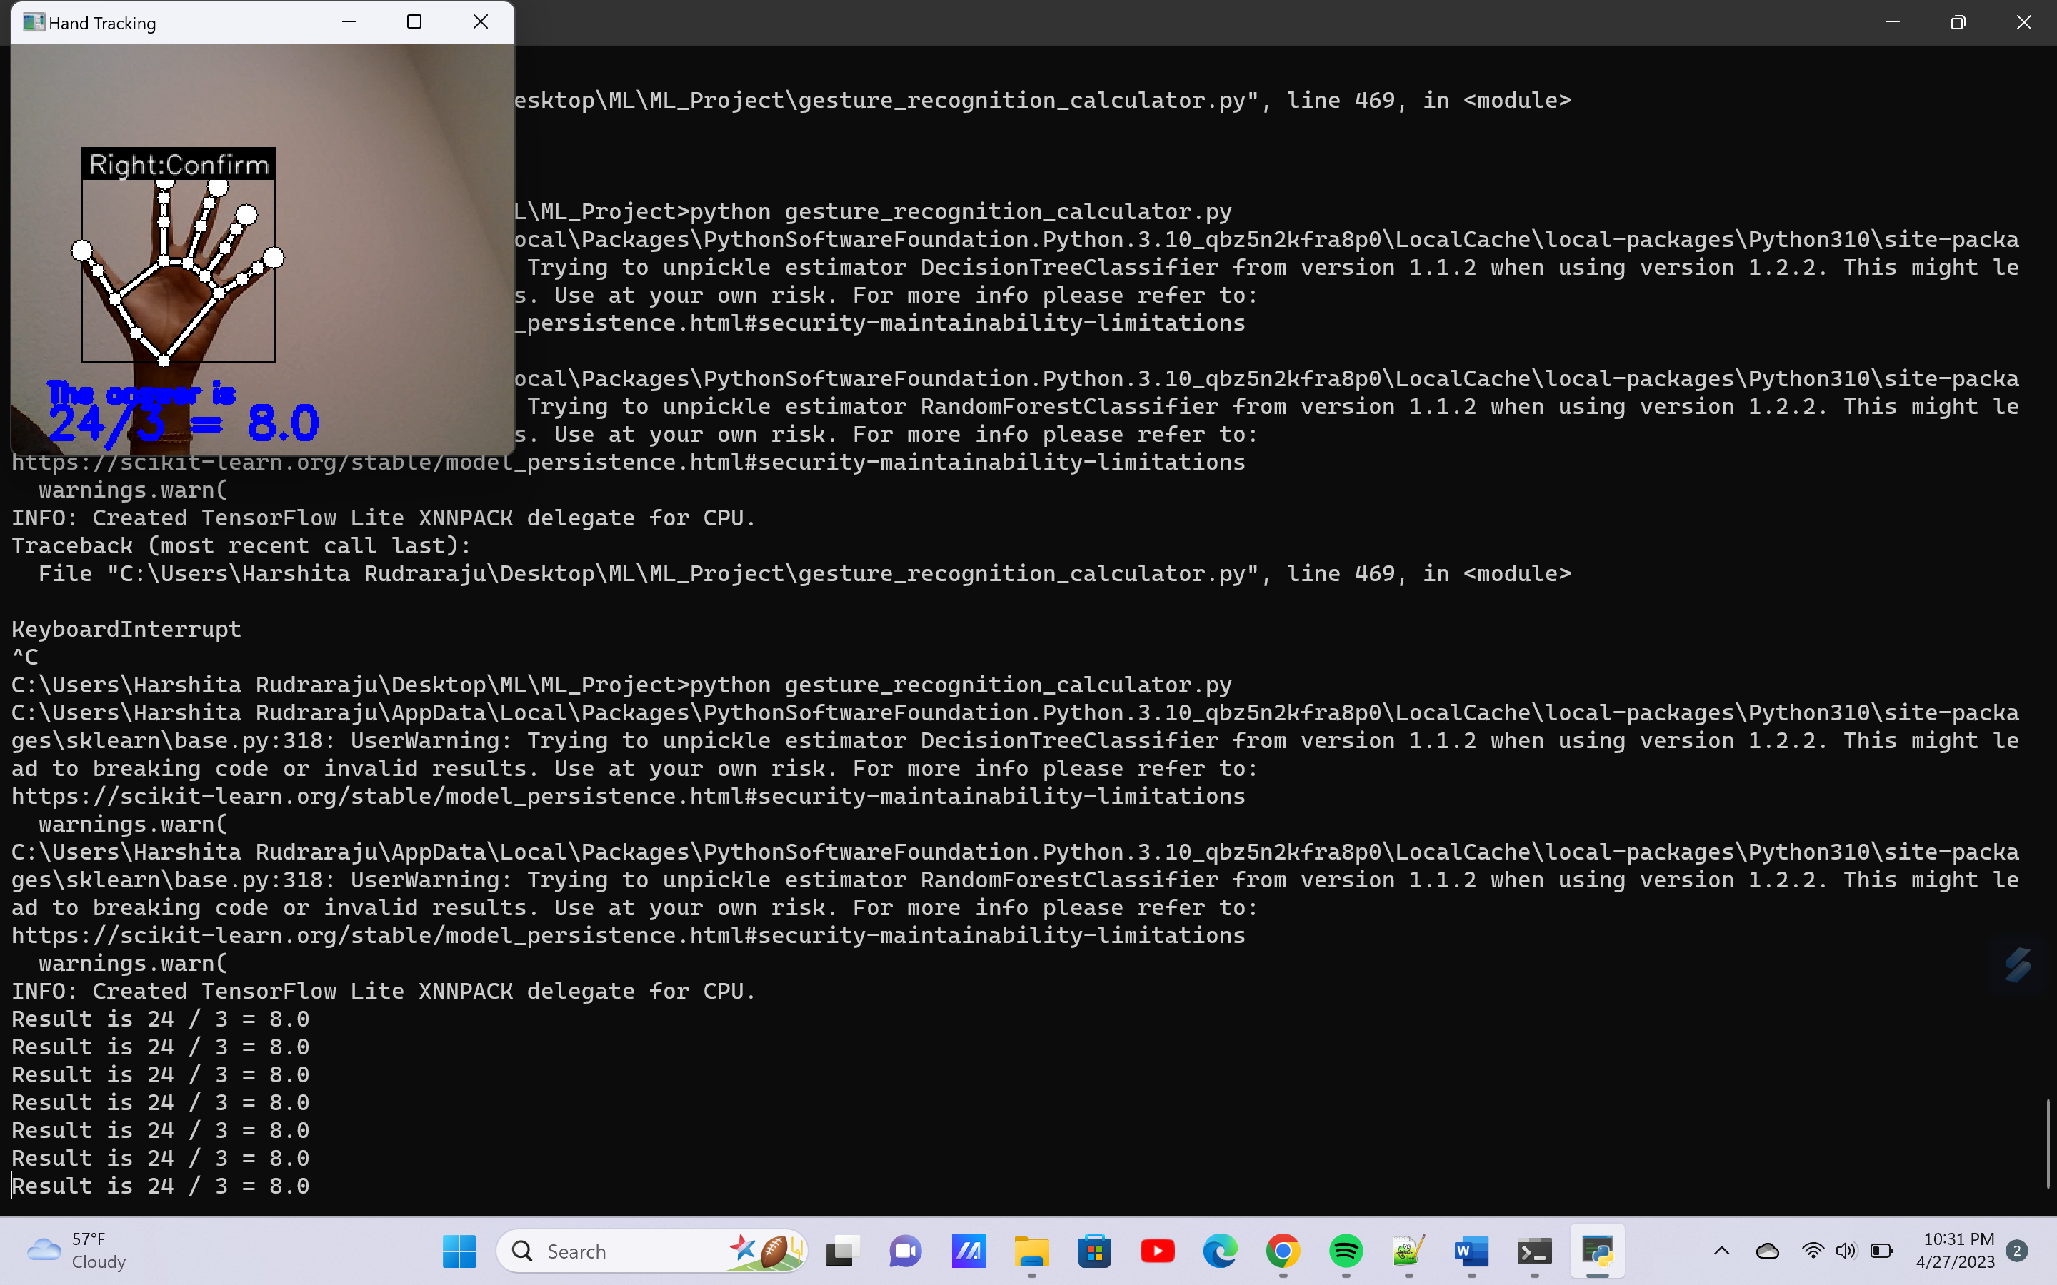

Fig. 12 Result from calculator operation

* Next, a message ‘Reset calculator?’ appears and the user can reset the calculator by showing ‘Clear’ gesture. Otherwise, the user may move the hand away from the webcam and show again to reset the calculator.
* Some error checking options have also been included in the virtual calculator. For e.g., if the user enters an operator ‘+’ as a number entry, then the result appears as ‘NA’. Similarly, if a number is entered in place of an operator, then the user sees the result as ‘NA’.